TraceNRecycle

A PROJECT REPORT

Submitted by

Himanshu (21BCS11403)
Aryan Pratap Singh (21BCS7508)
Dhruv Raj Vats (21BCS11469)

in partial fulfillment for the award of the degree of

BACHELOR OF ENGINEERING

IN

COMPUTER SCIENCE ENGINEERING


Chandigarh University

SEPTEMBER 2023


BONAFIDE CERTIFICATE

Certified that this project report “TraceNRecycle” is the bonafide work of “Himanshu, Aryan Pratap Singh and Dhruv Raj Vats” who carried out the project work under my/our supervision.

SIGNATURE

Dr. Sandeep Singh Kang

HEAD OF THE DEPARTMENT

SIGNATURE

Ashish Kumar

SUPERVISOR

Submitted for the project viva-voce examination held on

INTERNAL EXAMINER

EXTERNAL EXAMINER

TABLE OF CONTENTS
List of Figures i
List of Tables ii
Abstract iii
Graphical Abstract iv
Abbrevations v
Symbols vi
Chapter 1. 4

1.1 ..............................................................................................................................5

1.2 ................................................................................................................................

1.2.1 ........................................................................................................................

1.3 ................................................................................................................................

1.3.1 ........................................................................................................................

1.3.2 ........................................................................................................................

Chapter 2. ..................................................................................................................

2.1

................................................................................................................................

................................................................................................................................

2.2

................................................................................................................................

................................................................................................................................

Chapter 3. ..................................................................................................................

Chapter 4. ………………………….………………………………………...

Chapter 5. ……………………………………………………………………

References (If Any)....................................................................................................

List of Figures

Figure 3.1 ………………………………………………………………………………….

Figure 3.2 ………………………………………………………………………………….

Figure 4.1 …………………………………………………………………………….……

List of Tables

Table 3.1 ………………………………………………………………………………….

Table 3.2 ………………………………………………………………………………….

Table 4.1 …………………………………………………………………………….……
CHAPTER 1. INTRODUCTION

Client Identification/Need Identification/Identification of relevant Contemporary issue

The client for the TraceNRecycle project could be any entity or organization concerned with environmental sustainability and responsible waste management. This could include government agencies, environmental non-profits, recycling companies, or even manufacturers and retailers of products. The common need or identification for all potential clients is the pressing issue of improper disposal of non-recyclable or non-degradable items, such as glass bottles, electronic devices, and large furniture.

The contemporary issue addressed by the TraceNRecycle project is the improper disposal of non-recyclable or non-degradable items and its detrimental impact on the environment. Here's a breakdown of the relevant contemporary issues associated with this project:

Environmental Sustainability: Improper disposal of non-recyclable or non-degradable items leads to environmental pollution and harm. It contributes to landfills overflowing with items that could have been disposed of more responsibly. This issue is particularly relevant in the context of global efforts to combat climate change and reduce the carbon footprint.

Resource Conservation: Electronic devices and certain materials found in large furniture or glass bottles contain valuable resources that can be recycled or repurposed. Improper disposal means these resources are wasted, and more virgin materials are extracted to meet the demand, which depletes natural resources.

E-Waste Management: Electronic waste (e-waste) is a growing concern globally due to its toxic components and the increasing proliferation of electronic devices. Effective management of e-waste is crucial to prevent environmental contamination and health risks.

Accountability and Responsibility: Holding individuals or entities accountable for their product disposal practices is essential to discourage illegal dumping and promote responsible behavior. Without effective means of identifying product owners, enforcing accountability becomes challenging.

Technology Integration: The use of QR codes or barcodes as a solution to address improper disposal is a contemporary technological innovation. It leverages the prevalence of mobile devices and simplifies the process of tracking product ownership, making it relevant in our increasingly digital world.

Circular Economy: Encouraging responsible disposal and recycling is in line with the principles of a circular economy, where products and materials are reused, remanufactured, or recycled to reduce waste and minimize the environmental footprint.

Legislation and Regulations: Many governments are enacting stricter regulations and policies regarding waste disposal and recycling. Compliance with these regulations is vital for businesses and individuals, and technology like QR codes or barcodes can help ensure adherence.

Identification of Problem

The overarching problem that requires resolution in the TraceNRecycle project is the widespread occurrence of improper disposal of items that cannot be easily recycled or broken down naturally. These items encompass a range of materials, including glass bottles, electronic devices, and large furniture. The improper disposal of such items presents several critical issues:

- Environmental Impact: When non-recyclable or non-degradable items are disposed of improperly, they often end up in landfills, incinerators, or even littered in natural environments. This contributes to environmental harm by polluting the land, water, and air. For instance, electronic waste (e-waste) contains hazardous materials that can leach into the soil and groundwater.

- Resource Waste: Many of these items, such as electronics, contain valuable resources that can be recovered through recycling or proper disposal. When not handled correctly, these resources go to waste, leading to increased demand for virgin materials, resource depletion, and increased manufacturing energy costs.

- Aesthetic and Public Health Concerns: Improperly discarded items create eyesores in communities and may pose health hazards. Littered furniture and glass bottles can be safety hazards, while electronic waste may contain toxins that can harm both people and the environment.

- Accountability Challenges: Holding individuals or entities accountable for the responsible disposal of these items is difficult without an efficient and reliable tracking system. Current methods often rely on manual input of lengthy manufacturing numbers, which is time-consuming and error-prone.

- Regulatory Compliance: Governments and environmental agencies are increasingly implementing regulations and policies to manage waste disposal and promote recycling. Ensuring compliance with these regulations is essential but can be challenging without effective tracking and identification systems.

Identification of Tasks

The tasks required to identify, build, and test the TraceNRecycle project solution, we can structure our report into several chapters and sections. Here's a framework for our report:

- Research and select a suitable QR code or barcode technology. Develop a system for generating and affixing QR codes or barcodes during the manufacturing process. Ensure compatibility with various product types (glass bottles, electronic devices, furniture).
- Establish a secure database to store product information and owner data. Create a data structure to link QR codes/barcodes with product and owner details. Implement data encryption and security measures to protect user information.
- Collaborate with retailers to integrate the QR code/barcode system into their sales processes. Develop a protocol for retailers to record product ownership during purchase transactions.
- Design and develop a user-friendly mobile application for scanning QR codes/barcodes. Ensure cross-platform compatibility (iOS and Android).
- Develop educational materials and campaigns to inform consumers about the TraceNRecycle system. Train retailers and consumers on how to use the mobile application and the importance of responsible disposal.
- Conduct rigorous testing of the QR code/barcode system, database, and mobile app to ensure reliability and accuracy. Identify and resolve any technical issues or bugs.
- Ensure compliance with data protection and privacy laws. Draft user agreements and privacy policies for the mobile app.
- Launch the TraceNRecycle system in a selected region or with a pilot group of products. Monitor system performance and user adoption.
- Implement ongoing monitoring of the system's effectiveness. Provide regular maintenance and updates for the mobile app and database.
- Analyze data collected through the system to track disposal patterns and identify areas for improvement. Generate reports on the impact of the TraceNRecycle system on reducing improper disposal.
- Continue public awareness campaigns to promote responsible disposal practices. Collaborate with environmental organizations and authorities to advocate for responsible waste management.
- Plan for the expansion of the TraceNRecycle system to cover more products and regions. Seek partnerships with manufacturers and retailers for wider adoption.
- Maintain detailed project documentation, including project plans, progress reports, and financial records. Prepare periodic reports for stakeholders and funding organizations.

Timeline

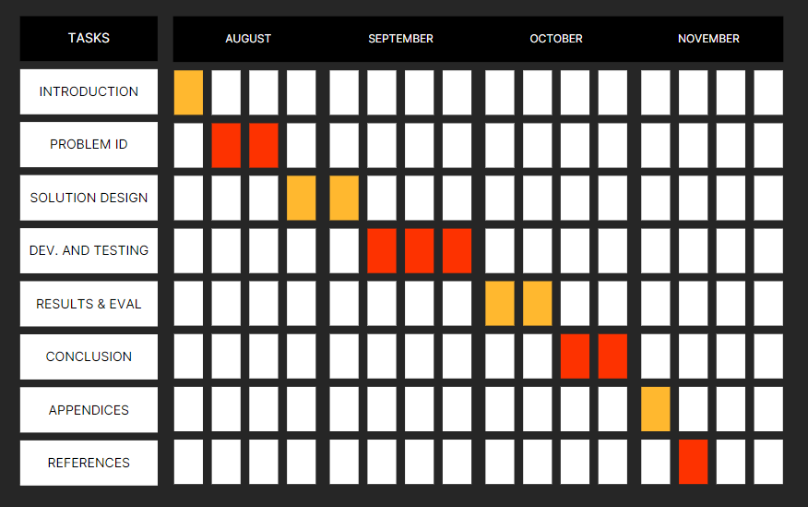
Figure 1.1: Gantt Chart

Organization of the Report

Here is a brief description of each chapter in a paragraph:

Introduction: In this chapter, we will introduce readers to the TraceNRecycle project, its context, and the urgency of addressing the issue of improper disposal of non-recyclable items. We will outline the objectives of the report, providing a roadmap for what readers can expect to learn.

Identifying the Solution: This chapter delves into the research and analysis that led to the selection of QR codes and barcodes as the solution for TraceNRecycle. It explains why these technologies were chosen and highlights their advantages in addressing the problem.

Design and Development: Here, we will describe the technical aspects of the project. This includes the architecture of the system, the integration of QR codes and barcodes into the manufacturing process, data storage, security measures, and the development of the mobile app for scanning. We will also discuss compliance with relevant regulations and standards.

Testing and Quality Assurance: This chapter focuses on the testing phase of the project. It explains the types of tests conducted, the testing strategy, and the results obtained. Additionally, we will address bug tracking, resolution, and the incorporation of user feedback to improve the system.

Implementation and Deployment: Detailing the actual rollout of TraceNRecycle, this chapter covers the practical aspects of implementation, including training for manufacturers, retailers, and consumers, as well as the establishment of monitoring and support mechanisms. If applicable, plans for scaling the system may also be discussed.

Results and Impact: Here, we will provide a comprehensive evaluation of the project's impact. We'll present measurable results, such as the reduction in improper disposal incidents, environmental impact assessments, and a cost-benefit analysis, offering a clear picture of the project's effectiveness.

Challenges and Lessons Learned: This chapter addresses the obstacles encountered during the project's lifecycle. We will discuss technical challenges, user adoption issues, and how regulatory and privacy concerns were managed. Valuable lessons learned will be shared to benefit future projects.

Conclusion: In the concluding chapter, we will summarize the key achievements of the TraceNRecycle project and reiterate its significance. We may also outline future plans and enhancements to sustain and improve the solution.

Appendices: This section includes supplementary material such as technical specifications, sample QR code/barcode templates, and user guides, providing readers with additional resources for understanding and implementing the solution.

References: In the final chapter, we will cite all the relevant sources, standards, and regulations that informed the development and execution of the TraceNRecycle project. This ensures the credibility of our report and allows readers to explore the source materials further.

